

**Research Analyst:**

**Minh Nguyen Viet Quang**

*(definitely not financial advice)*

**Intel Corporation (INTC)**

Amidst the frenzy surrounding the recent AI boom and escalating geopolitical tensions following rumors of a potential Chinese invasion, the investment community seems to have largely forgotten about Intel Corporation (INTC). Once the undisputed leader in the semiconductor space, Intel has taken a backseat as the spotlight has shifted towards AI companies and upstart rivals like AMD.

The resurgence of AMD starting in 2014, with its compelling Zen CPU lineup, has been a remarkable underdog story. AMD initially positioned itself as the value champion, offering great performance at competitive price points relative to Intel's offerings. This narrative, coupled with a dedicated fanbase of "AMD fanboys", has further fueled AMD's rise and grabbed investor attention.

As AMD shed its value-focused strategy and began pricing its products more in line with Intel's premium segments, the competitive dynamics shifted. Intel, which had long enjoyed performance leadership, suddenly found itself being outmaneuvered by its resurgent rival on multiple fronts.

**Intel has experienced a significant fall from grace**, with both its revenue streams and investor mindshare taking a hit[1]. The company's struggles have been further exacerbated by the AI frenzy and geopolitical uncertainties, which have diverted attention and capital away from traditional semiconductor players like Intel.

Despite the challenges Intel has faced from intensifying competition and the recent frenzy around AI and geopolitical events, **we should still consider the semiconductor giant as a worthwhile investment opportunity.**

**Firstly, Intel has embarked on strategic initiatives** aimed at regaining its manufacturing process leadership through accelerated innovation.

**Secondly,** coupled with **a robust product roadmap spanning next-generation CPUs, GPUs, FPGAs and more,** these efforts position Intel favorably to capitalize on long-term industry trends, regaining its manufacturing process leadership through accelerated innovation.

**Thirdly, Intel's current valuation metrics proves attractive**, and it is where we can potentially witness Pat Gelsinger’s execution prowess.

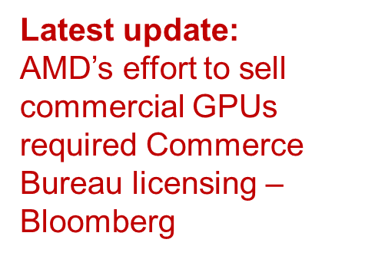



# Pat’s Power Play

#### AMD’s Awkward Footing, NVIDIA’s “grokking”

While NVIDIA has emerged as an imposing force in accelerated computing, AMD remains Intel's most direct rival as the primary x86 CPU competitor. Despite NVIDIA's GPU dominance, AMD's resurgence in CPUs poses the more existential threat to Intel's core business and market share:

* AMD's comeback in CPUs was aided by piggybacking on Intel's x86 architecture license
* For CPUs, AMD could engineer and optimize atop of x86 licensed designs
* But AMD GPUs have no equivalent "x86" architecture - AMD must build from scratch
* AMD's GPU efforts like CDNA, RDNA, ROCm and Instinct pale in comparison to NVIDIA's monoliths[2]
* NVIDIA has fortified their GPU ecosystem with software like CUDA deeply embedded
* CUDA's early domination in ML (e.g. Theano at UMontreal) created daunting ecosystem lead[3]
* AMD's ROCm GPU compute stack lacks documentation, enterprise adoption compared to CUDA[4]
* Even Intel's newer OneAPI *(wrapped SYCL)* is showing more promise as open, community-driven
* AMD is cash poor after years of underperformance, lacking R&D firepower of NVIDIA/Intel and pales in engineering headcount
* While AMD clawed back in CPUs, repeating the feat in GPUs seems improbable

**The crux is that AMD's GPUs, lack that shared architectural basis, forcing an expensive "clean room" design implementation.** Currently:

* NVIDIA's GPUs have become the de facto standard for AI training workloads[5][6]
* However, AI inference, especially Large Language Models (LLMs), favors different architectures[7]
* Upstarts like Groq have released LPUs optimized for blazing fast LLM inference claims over 20x faster inference performance vs comparable NVIDIA GPUs[8]
* As AI/LLM use cases shift to production, faster inference becomes paramount
* Enterprise adoption will gravitate to inference acceleration for user experience

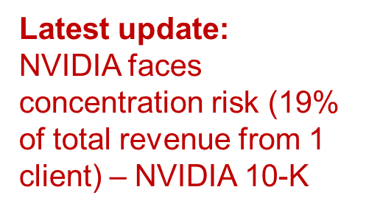



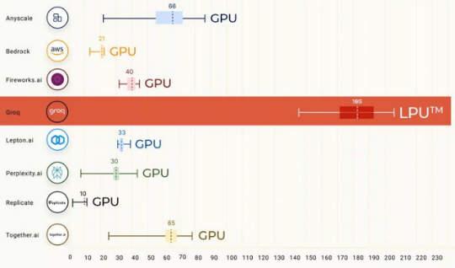

**Image 1:** Groq LPU output vs GPU (Appendix 2)

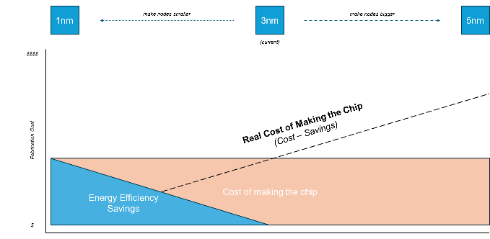

**Diagram 1:** Node manufacturing total cost offset by savings (Appendix 3)

* E.g. Faster LLM responses drastically improve chatbot/query interactions
* This leaves NVIDIA's GPU strengths limited to traditional ML training use cases
* NVIDIA at risk of ceding lucrative data center inference share to LPU vendors
* OpenAI's pivotal Sora video generation may be NVIDIA's last stronghold in AI[9]

The key point is that while NVIDIA GPUs have been instrumental for ML training, the booming LLM inference workloads actually favor novel accelerator architectures like LPUs over general-purpose GPUs. Upstarts like Groq claim over an order of magnitude performance lead for LLM inference.

As AI transitions from training to production deployment, fast inference will become critical for user experience with text generation, chatbots, querying etc. NVIDIA risks losing its data center compute dominance in these areas to accelerator vendors.

This potentially relegates NVIDIA to handling only traditional ML training scenarios, with novel AI tasks like OpenAI's Sora video generation being one of the last bastions in the current *content-generating-AI* space before LPU vendors make further inroads.

### Quantum Tunneling

* For decades, Moore's Law projected exponential transistor density growth[10]
* However, quantum effects fundamentally limit scaling below ~1nm nodes[11]
* The performance/cost returns diminish drastically past this point
* Intel's CEO Pat Gelsinger probably recognized this *(he started the Tunnel Falls quantum silicon project)*
* Relentless lithography shrinks alone are no longer sustainable long-term
* Gelsinger set Intel on a strategic pivot to diversify into foundry services[12]
* Leveraging Intel's revitalized 18A (1.8nm) process technology leadership[13]
* And taking advantage of lucrative CHIPS Act subsidies for domestic fabs[14]
* Intel's heritage as an integrated device manufacturer (IDM) is a key strength



* Can provide comprehensive solutions from design to manufacturing
* Contrasted with fabless players and pure-play foundries like TSMC
* Positions Intel to capture outsourced foundry demand and diversify revenue
* While continuing to develop its own products on bleeding-edge nodes

Gelsinger probably recognized that the classical Moore's Law model of ever-smaller lithography shrinks has fundamental physical limits around the 1nm node due to quantum effects *(we might as well start making portable quantum computers)*. Extracting performance/cost past this inflection point becomes extremely difficult.[15]

This realization led to Intel's strategic shift to position itself as a major foundry services provider in addition to its internal chip manufacturing. Leveraging its domestic 18A process leadership, bolstered by CHIPS Act subsidies, while its integrated device manufacturing heritage gives it an advantage over fabless firms or pure-play foundries.

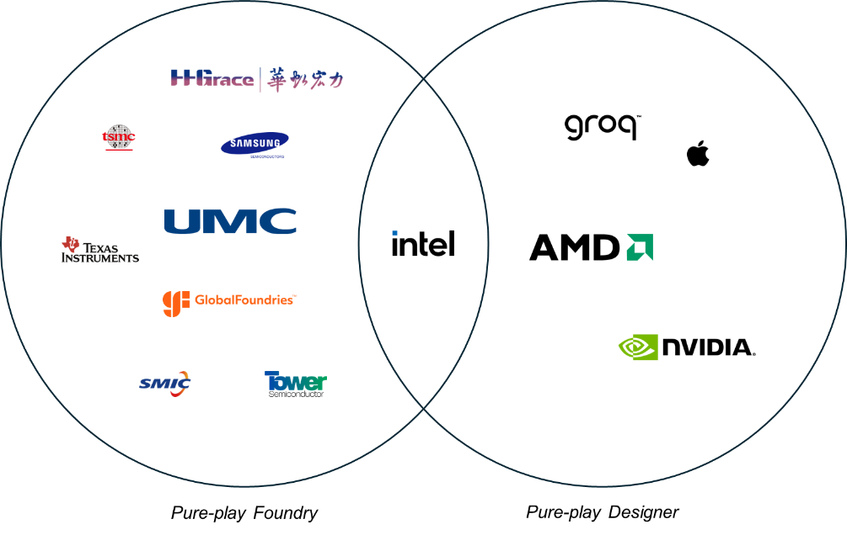

With the U.S. CHIPS Act providing lucrative subsidies to incentivize domestic semiconductor manufacturing, Intel stands to be a prime beneficiary being one of the few remaining major IDMs. In contrast, fabless players like AMD, NVIDIA, and ARM rely entirely on third-party foundries like TSMC and cannot directly capitalize on the manufacturing subsidies. Likewise, pure-play foundries miss out on benefiting from the design/IP side of chip development.

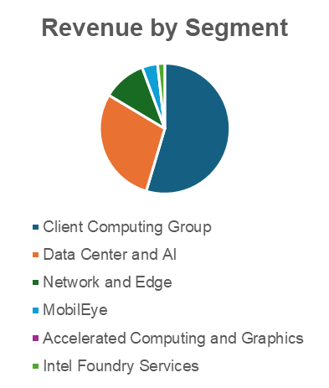

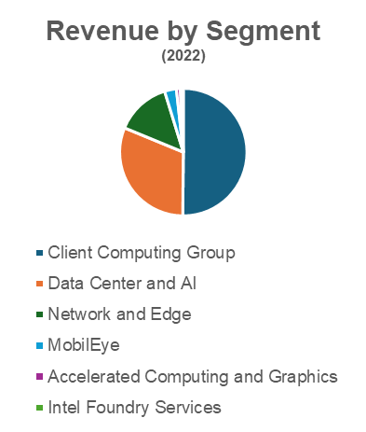

This positions Intel in an enviable sweet spot - able to develop both advanced manufacturing processes and cutting-edge chip designs under one roof, while having the option to offer foundry services using its process prowess. **Samsung and Texas Instruments** are the only other major IDM players that enjoy similar benefits. **(But their CPUs and R&D sucks which leaves them a few years behind Intel).**[16]

# Intel’s Call Options

Internally, Intel is focused on rebuilding key business units like the Data Center and AI (DCAI), Network and Edge (NEX), and Client Computing (CCG) groups under Gelsinger.

The recent Mobileye IPO unlocked new capital while retaining majority ownership. With revenues up 10% from 2022’s results, versus my estimation of 7% *(which was already very optimistic)*.[17]

Critically, Intel is aggressively expanding its foundry services capabilities - straddling in-house design and third-party manufacturing, capitalizing on Intel's integrated device manufacturing heritage as a geopolitics and strategic asset.

## CCG – Client Computing Group

### ARC

**Intel has embarked on a new consumer GPU roadmap under the Arc brand**, which launched in 2022 with the initial "Alchemist" products. This represents Intel's attempt to disrupt the consumer graphics market, akin to when AMD CEO Lisa Su set the company on a turnaround path with the Vega architecture for consumers in 2017. *(Vega flopped hard)*

The current Alchemist lineup of Arc GPUs is targeted squarely at media applications like video/image editing as well as gaming. Despite being Intel's pioneering consumer graphics products, the Arc GPUs have already generated significant attention and demand, with the Intel OEM **Arc A770 model selling out and receiving widespread praise across enthusiast forums.**[18]

Intel's entrance as a third major player in consumer graphics is viewed as a welcome development, as the Nvidia-AMD duopoly has faced criticism over opaque pricing practices failing to offer proportional performance-per-dollar for their GPUs. By evaluating metrics like the G3D benchmark score divided by retail pricing, a more transparent assessment emerges - one where Intel's Arc GPUs could rank favorably against incumbents if priced competitively to their capabilities.

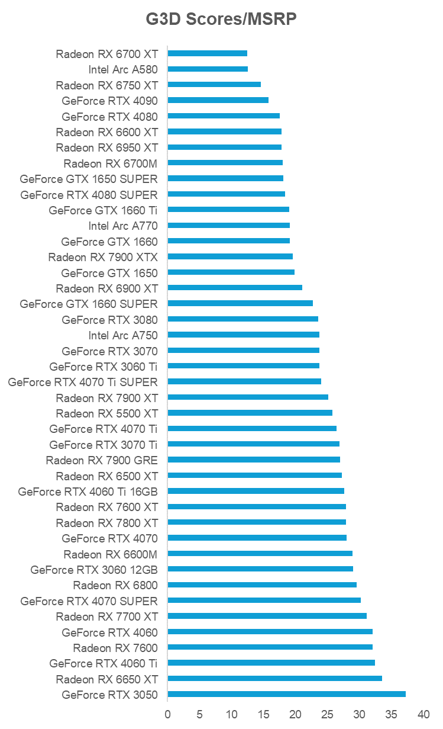

NVIDIA’s and AMD’s GPUs rank all over the place and is irrationally priced to value

**Graph 1:** G3D GPU benchmark scores to MSRP price ranking. Ranked by lowest to highest value (Appendix 4)

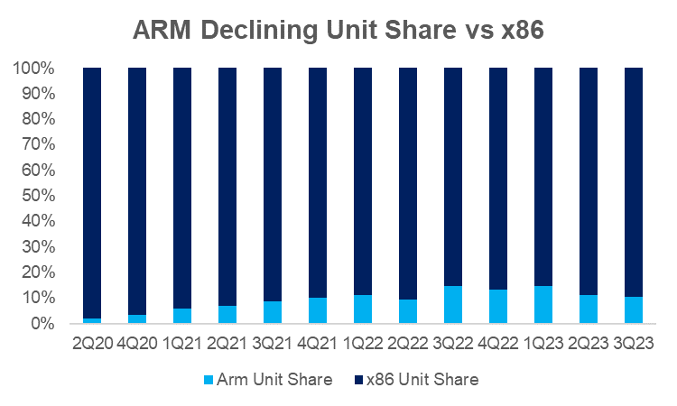

**Graph 2:** Declining ARM Unit Share versus x86 (Appendix 5)[22]

**With the Alchemist Arc GPUs already demonstrating performance parity with Nvidia's RTX 3070 out of the gate**, Intel has put the incumbent GPU giants on notice from the start. As Arc scale upwards, Intel's entrance as a legitimate third player in consumer graphics holds the promise of disrupting pricing norms and delivering greater value to consumers previously anchored to the Nvidia/AMD duopoly. *(Intel is also offering better customer support and driver releases)*[19][20]

**Within Intel's Client Computing Group (CCG), two main client segments exist - personal and corporate.** The personal client space encompasses laptops and PCs for design, gaming, and other consumer use cases. Conversely, the corporate client market utilizes laptops and PCs primarily for productivity tasks like Microsoft Office suites and Adobe software.

A key differentiator is the graphics solution employed - integrated GPUs (iGPUs) versus discrete GPUs (dGPUs). iGPUs are integrated onto the primary processor, while dGPUs are separate graphics cards. Both can be configured in laptops, while desktops can house iGPUs alongside dGPUs or dedicated GPUs.

**Historically, there have been two camps - those seeking maximum performance from the hardware, and those prioritizing adequate on-the-go graphics capabilities for productivity.** Intel has disrupted this landscape by releasing its Arc iGPUs alongside Arc desktop GPUs that have surpassed AMD's Radeon integrated graphics.

This development leaves little room for AMD's loyalists, as Intel's new **Arc iGPUs have leapfrogged the performance of even the latest Radeon Vega 11 iGPU by +165%** (comparable to the GTX 1650 Mobile Max-Q dGPU)[21]. With such a commanding lead, there is scant incentive for corporate or consumer purchases to opt for AMD's integrated graphics anymore. Even Microsoft has pivoted back to Intel's x86 chips, abandoning AMD and Qualcomm's ARM-based efforts.

While Apple's M3 chips in MacBooks pose competition in the personal client space, their premium pricing and niche appeal limit their inroads into Intel's corporate stronghold, where legacy x86 dominates due to the costly transition risks of adopting new instruction set architectures.

By delivering substantial iGPU performance leads, new consumer graphics products – Intel has neutralized AMD's previous integrated graphics advantage, potentially cementing its position across personal and corporate client computing segments.[23]

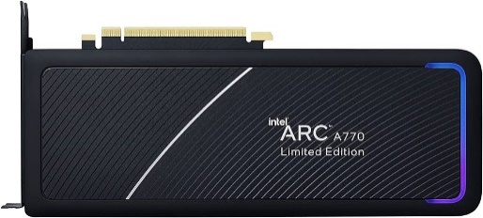

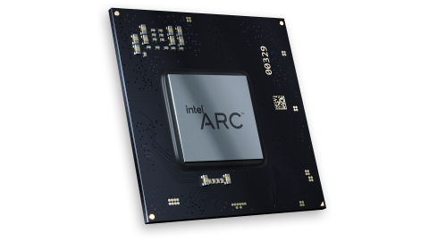

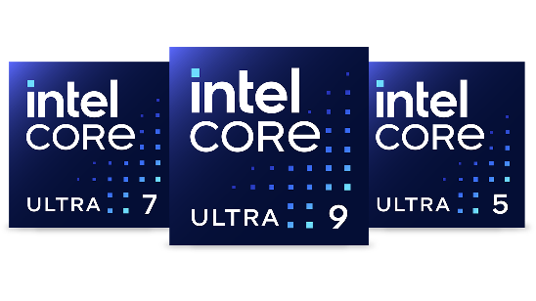

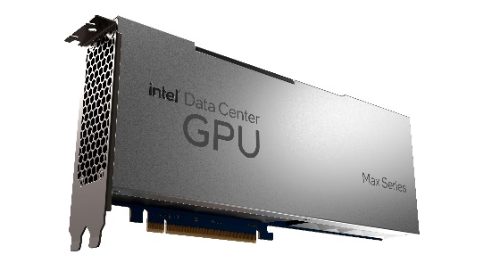

Amidst the buzz surrounding AI and data center markets, Intel's unassailable leadership in the PC CPU space seems to have faded from investor focus. However, an objective look at the benchmarking data paints a clear picture – **Intel continues to decisively outperform AMD across desktop and mobile CPU segments.**[24]

In virtually every performance tier, Intel secures the top four ranking positions when benchmarking the leading CPUs for both desktop and laptop use cases. This comprehensive performance leadership from Intel holds true even before accounting for typical retail pricing discounts that could further tilt value propositions in Intel's favor.

As it stands today, the highest performing, best-in-class CPUs across consumer desktop and mobile platforms unequivocally bear the Intel brand. Yet, there persists an inexplicable undercurrent of sentiment bestowing AMD with a perceived leadership position – a fallacy seemingly propagated by diehard AMD enthusiasts reveling in copium-laced narratives.

The reality is Intel's commanding performance lead in the PC CPU market remains intact and unchallenged. While AMD has undoubtedly made strides in closing competitive gaps, asserting outright leadership appears to be a misinformed perspective detached from empirical evidence.[25]

For investors evaluating Intel's positioning, the company's clear domination across PC CPU pricing and performance segments cannot be understated. As the highest revenue generator for Intel currently, this sustained prowess in its traditional CPU stronghold serves as a critically stable foundation for the chipmaker to fund strategic endeavors into emerging domains like AI and data center accelerators.

# DCAI – Data Center and AI

### Falcon Shores vs H100 vs MI300X

**Intel is making a decisive push into the booming AI market with its upcoming Falcon Shores GPU**, a converged solution merging the Ponte Vecchio GPU, Data Center GPU Max series, and Gaudi AI accelerators into a new all-purpose DCAI GPU product offering.[26]

This strategic move positions Intel to directly challenge Nvidia's current dominance with the H100 GPU while contesting AMD's charge with the highly memory-dense MI300X accelerator. High Bandwidth Memory (HBM) capacity has emerged as a critical differentiation point, with AMD's MI300X boasting an industry-leading 192GB of HBM, compared to Nvidia's 80GB HBM on the H100.[27]

**Intel appears well-poised**, with its current Gaudi 2 already packing 96GB of HBM, while the upcoming Gaudi 3 is rumored to raise the bar further to 144GB while delivering 1.5x increased compute performance. Moreover, **Intel's Data Center GPU Max 1550 with its 128GB of RAM is already outperforming the H100 by nearly 30% on benchmarks.** The only downside is that it consumers nearly 1000W versus NVIDIA’s 600W H100.[28]

As Intel converges these high-performance compute and AI components into the Falcon Shores platform, it signals the chipmaker's determined re-entry into a market it had previously ceded to Nvidia and AMD. However, mindshare remains a challenge, with the echo chambers amplifying Nvidia's Jensen Huang and AMD's Lisa Su while Intel's efforts garner relatively muted attention.[29]

Nevertheless, **if Intel can effectively bundle its HBM-dense and high-compute offerings while avoiding the supply constraints and pricing games Nvidia has been accused of**[30]**, it could disrupt the current AI accelerator landscape.** **Data center providers cite HBM capacity, vendor-agnostic compatibility and infrastructure availability as crucial requirements**, areas where Intel's converged Falcon Shores GPU could potentially deliver a compelling solution.

OneAPI, One for All

The current AI software ecosystem is dominated by Nvidia's CUDA, which gained the early mover advantage by allowing researchers at the University of Montreal to develop the pioneering Theano library atop its architecture. AMD's ROCm emerged as a competitive counter to Intel's SYCL, as AMD was unwilling to adopt SYCL due to perceived risks of Intel leveraging it for anticompetitive behaviors.

Into this fray, Intel has introduced its OneAPI stack, built upon the SYCL open standard. While the relative merits of CUDA, ROCm, and OneAPI ignite spirited debates, their relevance is somewhat diminished for AI workloads. **Most AI developers target high-level frameworks like PyTorch and TensorFlow, which now provide backend support across CUDA, ROCm, and OneAPI. All of those have backends by now and will get improved with time.**[31]

This levels the playing field, allowing AI developers to leverage hardware from Nvidia, AMD or Intel without being excessively locked into proprietary software stacks. As AI frameworks continue maturing their multi-vendor backend support, the AI software ecosystem appears poised to become increasingly hardware-agnostic over time.[32]

## 

## NEX – Networking and Edge

### SmartNICs – Intel’s IPU vs NVIDIA’s DPU

Intel's Networking and Edge (NEX) group stands to be a key beneficiary if the company's revamped Data Center and AI (DCAI) efforts gain traction. The NEX portfolio encompasses networking solutions, Ethernet products, and critically, Data Processing Units (DPUs)/SmartNICs rebranded as Infrastructure Processing Units (IPUs).

The importance of open, vendor-agnostic infrastructure has been underscored by NVIDIA’s Ethernet chief, Ram Velaga, who stated, "There is nothing unique about (our) device…The whole reason why Ethernet is successful today is it's a very open ecosystem." This aligns with the **industry's overarching trajectory towards embracing open standards and avoiding proprietary lock-ins.**[33]

For AI powerhouses like OpenAI and Anthropic, maintaining flexibility to pivot between hardware vendors based on availability and pricing is paramount. Nvidia has faced accusations of engaging in anticompetitive practices to inhibit such mobility. In this context, open frameworks like Intel's OneAPI that allows different hardware targeting become highly attractive.[34]

**Intel's current IPU roadmap is on par with Nvidia's Bluefield-2**, both offering 200Gbps Ethernet capabilities. Furthermore, Intel has already demonstrated the IPU's value proposition through a custom Google deployment resulting in an 88% NGINX performance uplift and 40% increase in MySQL throughput. To compete with NVIDIA’s Spectrum-X (packaged DPU and Ethernet unit) and the current Bluefield-3 (400GB/s). Intel is aiming to release a 800GB/s IPU in 2025.[35]

If Intel's revitalized DCAI group, bolstered by the converged Falcon Shores GPU, manages to reclaim market share, the NEX group is strategically positioned to capitalize on the collateral infrastructure spend. **An Intel DCAI renaissance would provide a powerful tailwind for the often-overlooked NEX group's prospects.**[36]

# Attractive Financials



A crucial factor to highlight is Intel's currently elevated cost of sales ratio hovering around 60%. This is attributable to the company's aggressive ramp-up efforts and associated costs as it scrambles to regain leadership across multiple fronts after years of mismanagement. CEO Pat Gelsinger has acknowledged this financial burden and expressed his commitment to streamlining operations for improved profitability.

**I forecast Intel's cost of sales ratio could realistically moderate to around 50% over the next few years.**[37] ***(While keeping a timid revenue growth estimate)* This would translate to a substantial boost in gross margins**, especially as the company scales its high-margin foundry services business. For context, industry leaders like TSMC and Nvidia boast gross margins of 53% and 75% respectively, while AMD sits at 47%.



Additionally, as Intel transitions towards an asset-light foundry model akin to TSMC, it could adopt more aggressive depreciation and amortization policies. TSMC depreciates its assets over a 5-year schedule compared to my assumption of a modest 10-year timeline. Modeling a 5-year depreciation strategy for Intel could unlock discounted cash flow valuations in excess of $200 per share for the company.

Even under a more conservative 10-year depreciation assumption, the increased cash flow tailwinds from optimized cost structures and foundry economics position Intel's valuation at around $111 per share based on discounted cash flow analyses.

Moreover, with the Federal Reserve signaling interest rate declines, Intel could capitalize on opportunities to refinance its outstanding debts for fabrication plant investments at lower rates, further bolstering free cash flow generation.



In essence, while Intel's ramp-up costs have currently depressed margins, **the company's pivot to a leaner foundry-intense model coupled with prudent financial management could unveil tremendous upside as operational and balance sheet efficiencies are realized.**

Despite current challenges, Intel remains a crucial strategic asset for the U.S., making it an unlikely candidate for an unmitigated failure, especially given the geopolitical importance of semiconductor capabilities. As an American tech titan, Intel could represent an extremely attractive value over the next decade, even if it simply executes reasonably well on a few key fronts.

The company's legacy in CPU design and manufacturing process leadership provides a stable foundation. However, the real upside emerges from Intel's aggressive moves into AI-optimized hardware like the Gaudi 3 accelerator, the converged Falcon Shores GPU, and future Xeon CPUs aimed at dethroning AMD's Epyc server chips. Additionally, the nascent Arc GPU roadmap unlocks new revenue streams beyond Intel's traditional domains.

While NVIDIA and AMD currently dominate mindshare, the AI/accelerator market remains at an inflection point, with ample room for disruption from credible challengers like Intel. The road ahead for AI development, spanning artificial general intelligence (AGI) and potentially artificial superintelligence (ASI), ensures intensifying competition will persist.

From an investor's perspective, Intel's depressed valuation presents an attractive entry point. Even in adverse scenarios, the company's criticality to American technological supremacy positions it as a "too vital to fail" entity, potentially safeguarding downsides.

As a former AMD enthusiast turned Intel observer. While AMD's value prop resonated during PC gaming's heyday, the landscape has transcended those roots. Intel's bold bets across AI, data centers, and next-gen architectures warrant circumspect evaluation, particularly for investors seeking exposure to this pivotal technological frontier.

**Overall, Intel emerges as a contrarian tech investment thesis** - an American semiconductor incumbent taking calculated risks to redefine its value proposition for the AI era, bolstered by unmatched strategic importance that could ultimately prove too vital to ignore.

# Considerable Factors

## Realization Risk

### AMD/NVIDIA secret projects

* What are they cooking?
* Could it leapfrog them ahead?

This risk is low because AMD or NVIDIA would have whipped it out to win the market already. And not just slowly releasing incremental products to look like they are “growing”[38][39]

### B100/X100/MI400

Gaudi 3 and Falcon Shores may or may not be able to rival. And we cannot ignore this risk. But I will find out a fact supported narrative to determine this soon. And to see if Intel is actually successfully developing and shipping or it’s just a marketing show.

## China

China could eat up Taiwan. Who knows?

NVIDIA moving to Vietnam wouldn’t save it either. The US would favor to push the supply chain back home, not just for safety measures but also for productivity and employment increase.

China could even take Vietnam too. They did just that with the Spratley islands in 2016.

## Pat Gelsinger and Intel messes things up

Possible. But it’s modestly low, since Intel was able to scoop up AMD’s GPU head, Apple’s M-Series pioneer, and a more key figures that would have expertise to call out things.

# Appendix

[1]

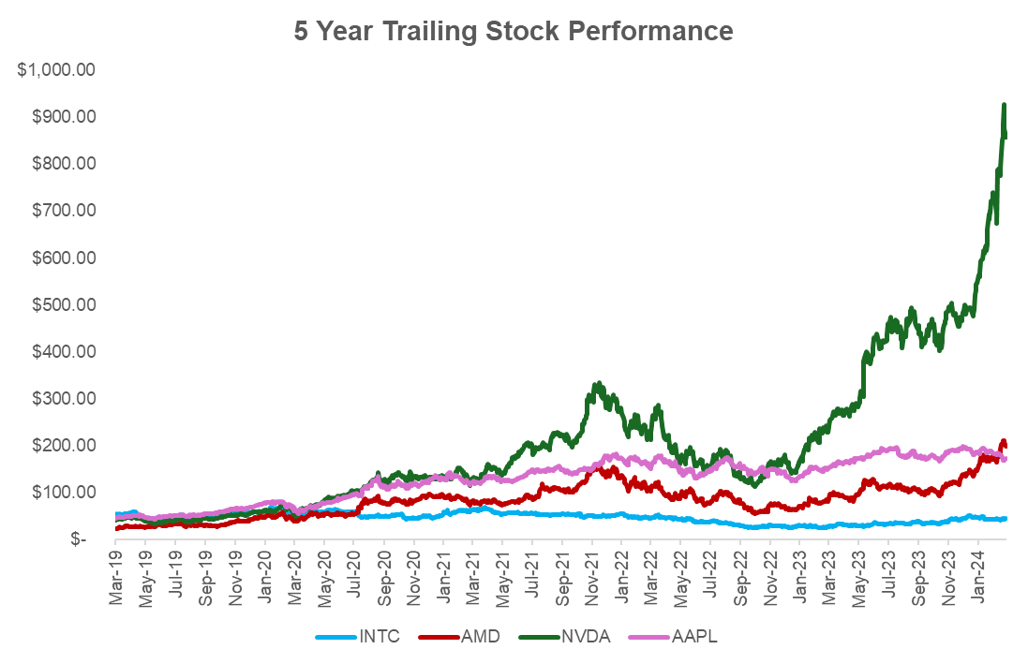

[2]

[3]

[4]

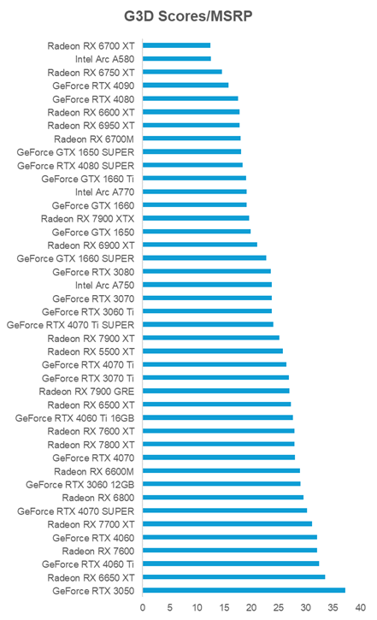

[5]

[6]

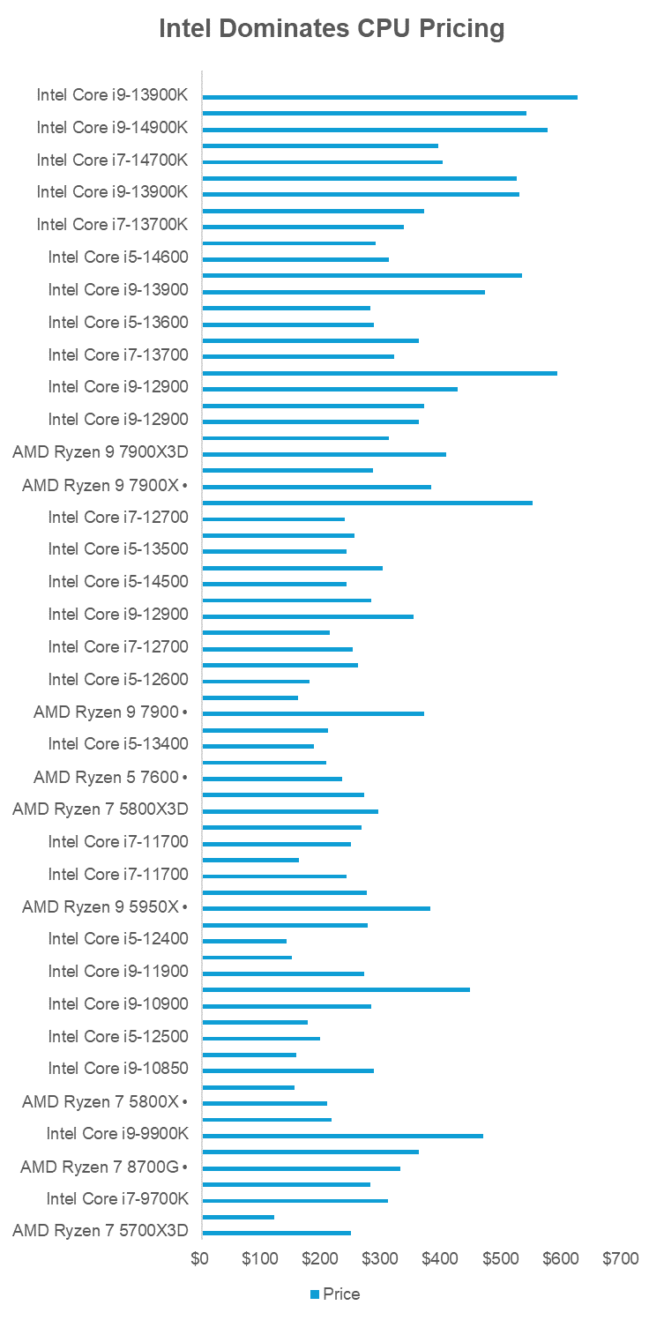

Intel dominates GPU pricing at every segment and ranks all within the top 100 – best on-the-market CPU list. Ranked by all time benchmarked performance from top (i9-13900k) to bottom (Ryzen 7 5700X3D).

[8]

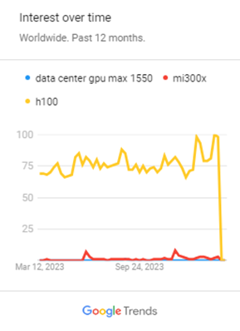

# References

1kg. (2023, August 7). *Nvidia’s CUDA Monopoly*. Retrieved from Medium: https://medium.com/@1kg/nvidias-cuda-monopoly-6446f4ef7375

1kg. (2024, January 19). *CUDA vs ROCm: The Ongoing Battle for GPU Computing Supremacy*. Retrieved from Medium: https://medium.com/@1kg/cuda-vs-rocm-the-ongoing-battle-for-gpu-computing-supremacy-82eb916fbe18

Dignan, L. (2024, February 21). *Intel Foundry sets roadmap, aims to be No. 2 foundry by 2030*. Retrieved from Constellation Research: https://www.constellationr.com/blog-news/insights/intel-foundry-sets-roadmap-aims-be-no-2-foundry-2030

Dorp, D. v. (2022, February 22). *Samsung’s horrible yield forces Qualcomm to give TSMC its business*. Retrieved from SamMobile: https://www.sammobile.com/news/samsungs-horrible-yield-qualcomm-give-tsmc-business/

Evanson, N. (2024, January 19). *Laptop makers just aren't interested in discrete Radeon GPUs and I really want AMD to do something about that, even though it won't*. Retrieved from PCGamer: https://www.pcgamer.com/laptop-makers-just-arent-interested-in-discrete-radeon-gpus-and-i-really-want-amd-to-do-something-about-that-even-though-it-wont/

Fehlis, Y. (2023, September 11). *Creating a PyTorch/TensorFlow Code Environment on AMD GPUs*. Retrieved from AMD GPUOpen: https://gpuopen.com/learn/amd-lab-notes/amd-lab-notes-pytorch-tensorflow-env-readme/

Fessi, A. (2024, February 20). *Why You Should Test Groq, and How Quicker it is Compared to ChatGPT and Gemini?* Retrieved from Medium: https://medium.com/@AhmedF/why-you-should-test-groq-and-how-quicker-it-is-compared-to-chatgpt-and-gemini-a5446b8d25c3

Framework Forum Members. (2022, October 1). *Intel Arc Availability sucks. Camping outside storefront.* Retrieved from Framework: https://community.frame.work/t/intel-arc-availability-sucks/23636

Freedman, A. (2023, December 14). *Intel CEO attacks Nvidia on AI: 'The entire industry is motivated to eliminate the CUDA market'*. Retrieved from Tom's Hardware: https://www.tomshardware.com/tech-industry/artificial-intelligence/intel-ceo-attacks-nvidia-on-ai-the-entire-industry-is-motivated-to-eliminate-the-cuda-market

Groq. (2024, February 13). *Groq LPU™ Inference Engine Crushes First Public LLM Benchmark*. Retrieved from Wow Groq: https://wow.groq.com/groq-lpu-inference-engine-crushes-first-public-llm-benchmark/

Hattori, T. (2021, June 2). *Past, Present, and Future of Moore's Law, which Supports the Advancement of the Semiconductor Industry*. Retrieved from Telescope Magazine: https://www.tel.com/museum/magazine/report/202106/

Intel. (2021, June 9). *Intel’s ‘IDM 2.0’ Strategy Defined in 60 Seconds*. Retrieved from Intel Newsroom: https://www.intel.com/content/www/us/en/newsroom/news/idm2-strategy-defined-60-seconds.html#gs.5pdipu

Intel. (2024, January 25). *Intel Annual Report*. Retrieved from Intel Investor Relations: https://www.intc.com/filings-reports/all-sec-filings/content/0000050863-24-000010/0000050863-24-000010.pdf

Intel Corporation. (2023, November 13). *data-center-gpu-max-series-product-brief*. Retrieved from Intel Site Backend: https://cdrdv2-public.intel.com/765361/data-center-gpu-max-series-product-brief.pdf

Intel NEX. (2022, May 10). *Intel Unveils Infrastructure Processing Unit Roadmap; 2nd Generation to Ship in 2022* . Retrieved from Intel Newsroom: https://download.intel.com/newsroom/2022/corporate/vision/Intel-IPU-Roadmap-Fact-Sheet.pdf

John Loeffler. (2023, October 16). *Intel Arc A770 review: a great 1440p graphics card for those on a budget*. Retrieved from TechRadar: https://www.techradar.com/computing/gpu/intel-arc-a770

Justin Badlam, S. C. (2022, October 4). *The CHIPS and Science Act: Here’s what’s in it*. Retrieved from McKinsey: https://www.mckinsey.com/industries/public-sector/our-insights/the-chips-and-science-act-heres-whats-in-it

Khuller, K. (2024, January 24). *Intel claims up to 268% gaming boost with latest Arc graphics drivers*. Retrieved from Digital Trends: https://www.digitaltrends.com/computing/intel-arc-driver-update-january-2024/

Kinsella, B. (2024, February 24). *NVIDIA is Officially the Giant of Generative AI*. Retrieved from Substack: https://synthedia.substack.com/p/nvidia-is-officially-the-giant-of#:~:text=competition%20every%20day.-,While%20AI%20model%20developers%20and%20cloud%20hyperscalers%20compete%20for%20customers,it%20at%20a%20lower%20cost.

Larabel, M. (2023, November 22). *AMD EPYC Genoa/Genoa-X & Bergamo vs. Intel Xeon Sapphire Rapids On Ubuntu 23.10*. Retrieved from Phoronix: https://www.phoronix.com/review/ubuntu-2310-epyc-xeon

makomk. (2023, June 3). *The trouble is that AMD just didn't take AI seriously*. Retrieved from Hacker News: https://news.ycombinator.com/item?id=36165139

Mall, F. (n.d.). *Broadcom vs. NVIDIA: The 400G/800G Switch Race*. Retrieved from Fiber Mall: https://www.fibermall.com/blog/broadcom-vs-nvidia-the-400g-800g-switch-race.htm

NVIDIA. (2024). *Jetson for AI Education*. Retrieved from NVIDIA: https://developer.nvidia.com/embedded/learn/jetson-ai-education

Patel, D., & Nishball, D. (2023, December 6). *AMD MI300 Performance - Faster Than H100, But How Much?* Retrieved from Semi Analysis Substack: https://www.semianalysis.com/p/amd-mi300-performance-faster-than

Pure Storage. (2022, September 22). *CPU vs. GPU for Machine Learning*. Retrieved from Pure Storage: https://blog.purestorage.com/purely-informational/cpu-vs-gpu-for-machine-learning/#:~:text=Some%20algorithms%20are%20also%20optimized,processing%20and%20massively%20parallel%20computations.

Q12024, B. E. (2024, March 7). *Traditional enterprise networking is kind of also in a bit of a slowdown now. AI will pickup.* Retrieved from The Motley Fool: https://www.fool.com/earnings/call-transcripts/2024/03/07/broadcom-avgo-q1-2024-earnings-call-transcript/

r/Hardware Forum. (2023, December 11). *ONE YEAR LATER: Intel Arc GPU Drivers, Bugs, & Huge Improvements*. Retrieved from Reddit: https://www.reddit.com/r/hardware/comments/185hxcd/one_year_later_intel_arc_gpu_drivers_bugs_huge/

Ramkumar, H. (2024, February 22). *Comparing GPU vs TPU vs LPU: The Battle of AI Processors*. Retrieved from Medium: https://medium.com/@harishramkumar/comparing-gpu-vs-tpu-vs-lpu-the-battle-of-ai-processors-2cf4548c4a62

Reyes, R. (2022, December 16). *Bringing Nvidia® and AMD support to OneAPI*. Retrieved from OneAPI: https://www.OneAPI.io/blog/bringing-nvidia-and-amd-support-to-OneAPI/

Shah, A. (2023, August 8). *Intel Plans Falcon Shores 2 GPU Supercomputing Chip for 2026*. Retrieved from HPCWire: https://www.hpcwire.com/2023/08/08/intel-plans-falcon-shores-2-gpu-supercomputing-chip-for-2026/

Shilov, A. (2023, November 10). *Arm, Apple's PC Market Share Shrinks as x86 Rebounds: Mercury Research*. Retrieved from Tom's Hardware: https://www.tomshardware.com/pc-components/cpus/arm-pc-market-share-shrinks-mercury-research

Sperling, E. (2018, May 23). *Quantum Effects At 7/5nm And Beyond*. Retrieved from Semiconductor Engineering: https://semiengineering.com/quantum-effects-at-7-5nm/

Technical City. (n.d.). *Intel Data Center GPU Max Subsystem vs NVIDIA H100 SXM5 96 GB*. Retrieved from Technical City: https://technical.city/en/video/H100-SXM5-96-GB-vs-Data-Center-GPU-Max-Subsystem

Tyson, M. (2024, February 7). *AMD takes market share from Intel in server, desktop, and notebooks — new Mercury Research data shows Q4 2023 data*. Retrieved from Tom's Hardware: https://www.tomshardware.com/pc-components/cpus/amd-takes-revenue-share-from-intel-in-server-desktop-and-notebooks-new-mercury-research-data-shares-q4-2023-data

Tyson, M. (2024, February 27). *Nvidia's AI customers are scared to be seen courting other AI chipmakers for fear of retaliatory shipment delays, says rival firm*. Retrieved from Tom's Hardware: https://www.tomshardware.com/pc-components/gpus/rival-firm-says-nvidias-ai-customers-are-scared-to-be-seen-courting-other-ai-chipmakers-for-fear-of-retaliatory-shipment-delays-report

Veerasingam, M. (2023, June 2). *Quantum Tunneling And The Semiconductors’ Struggle in the Miniaturization Race*. Retrieved from Medium: https://medium.com/@markveerasingam/quantum-tunneling-the-semiconductors-struggle-in-the-miniaturization-race-7ef2df8f9e48

金猪升级包. (2023, December 15). *酷睿Ultra H系列晚发评测：加强版7840HS*. Retrieved from Bili Bili: https://www.bilibili.com/video/BV1Wi4y1e7NN/?vd_source=c07ac9a57f0b62a027d8c35f9f03271c